**EX#1 – Coffee Mug Heat Transfer Simulation**

Problem Statement:

You have a cup of coffee and want to know how long it takes to cool to a nice drinking temperature, and also the time before it gets too cold to drink. First, look at how it would act with only conductive and convective heat transfer. Then force the initial coffee temperature and mug to be the temperature after initial heating. Next, model the mug and coffee while accounting radiative heat transfer. Then, model the mug and coffee while accounting for evaporative effects. Lastly, evaluate the effectiveness of the model against empirical data.

Given:

1. There is 0.41 L of coffee at 1 atm and 92°C.
2. The mug has an initial temperature of 21°C, mass of 0.365 kg, inner diameter of 0.083 m, inner height of 0.098 m, outer height of 0.109 m, and nominal wall thickness of 0.0040 m.
3. Drinkable coffee temperature is 60ªC and coffee is too cold at 45°C.
4. The convective coefficient of air, coffee to mug, and coffee to air are 6.8, 470, and 300 W/m2/K respectively.
5. The forced initial temperature is to be 81.7°C.
6. When modeling evaporative effects, the coefficient is 1 * 10-4 W/m2/K.

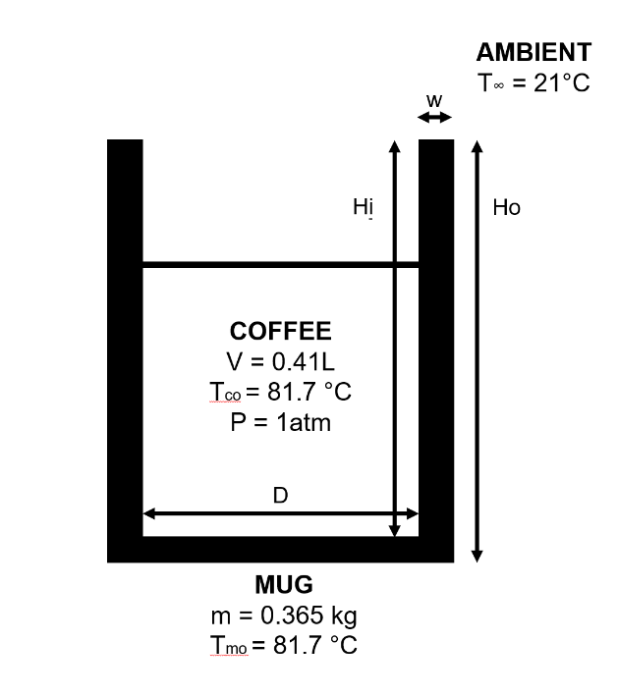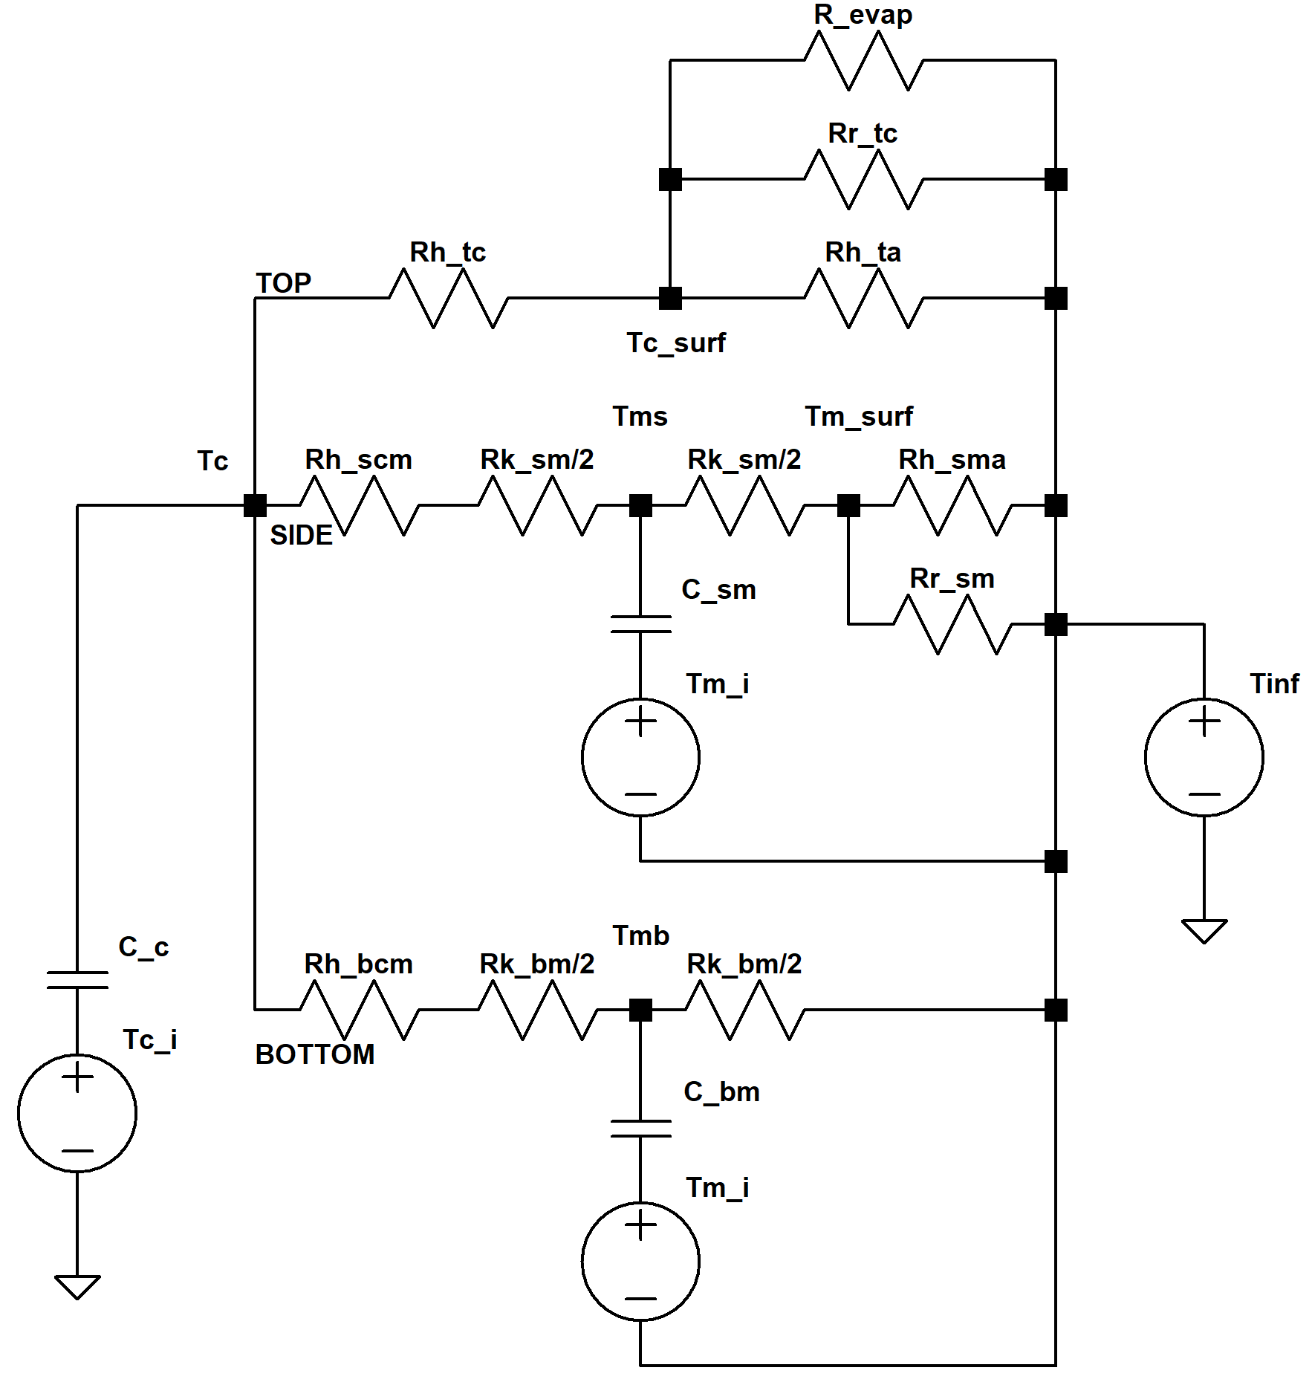

Results and Analysis:

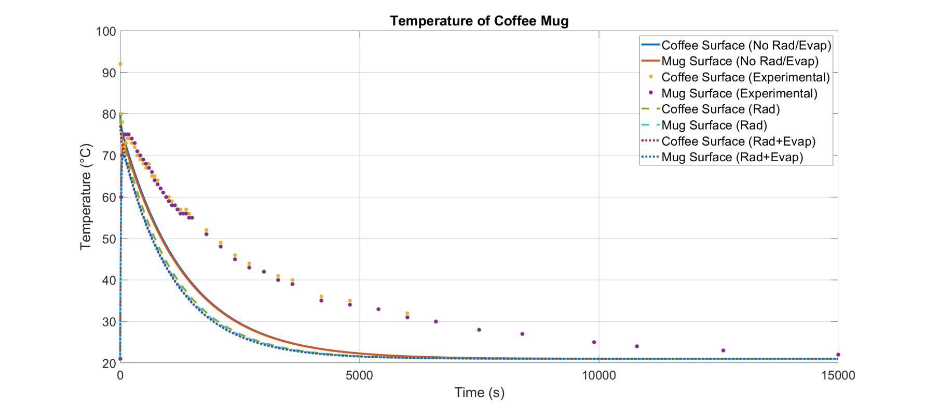Fig. 1: Plotting the Temperature of Coffee-Mug

This plot demonstrates the temperature change of the coffee mug (in components) over the span of a little over 4 hours – an acceptable amount of time to make coffee and get distracted by work. The first curves of interest are the solid blue curve and the solid red curve which represent a purely conductive and convective heat transfer. As shown in this graph, they have a higher magnitude of concavity than the experimental data while still having a similar shape. Furthermore, as more modes of heat transfer were added, the magnitude of concavity also decreased, but with diminishing returns. Looking at this graph, however, we gain the insight that no matter which model (with some degree of accuracy), the temperature will rise from an initial point, reach a peak, decrease with an inflection point, and eventually reach a steady state temperature – all reach an asymptote of the ambient room temperature, 21°C. This general description fits the logical prediction of how the coffee-mug system would act in this situation. Because each model fits the logical action, we now need to look more closely at the temperature curves to get a better understanding of the system.

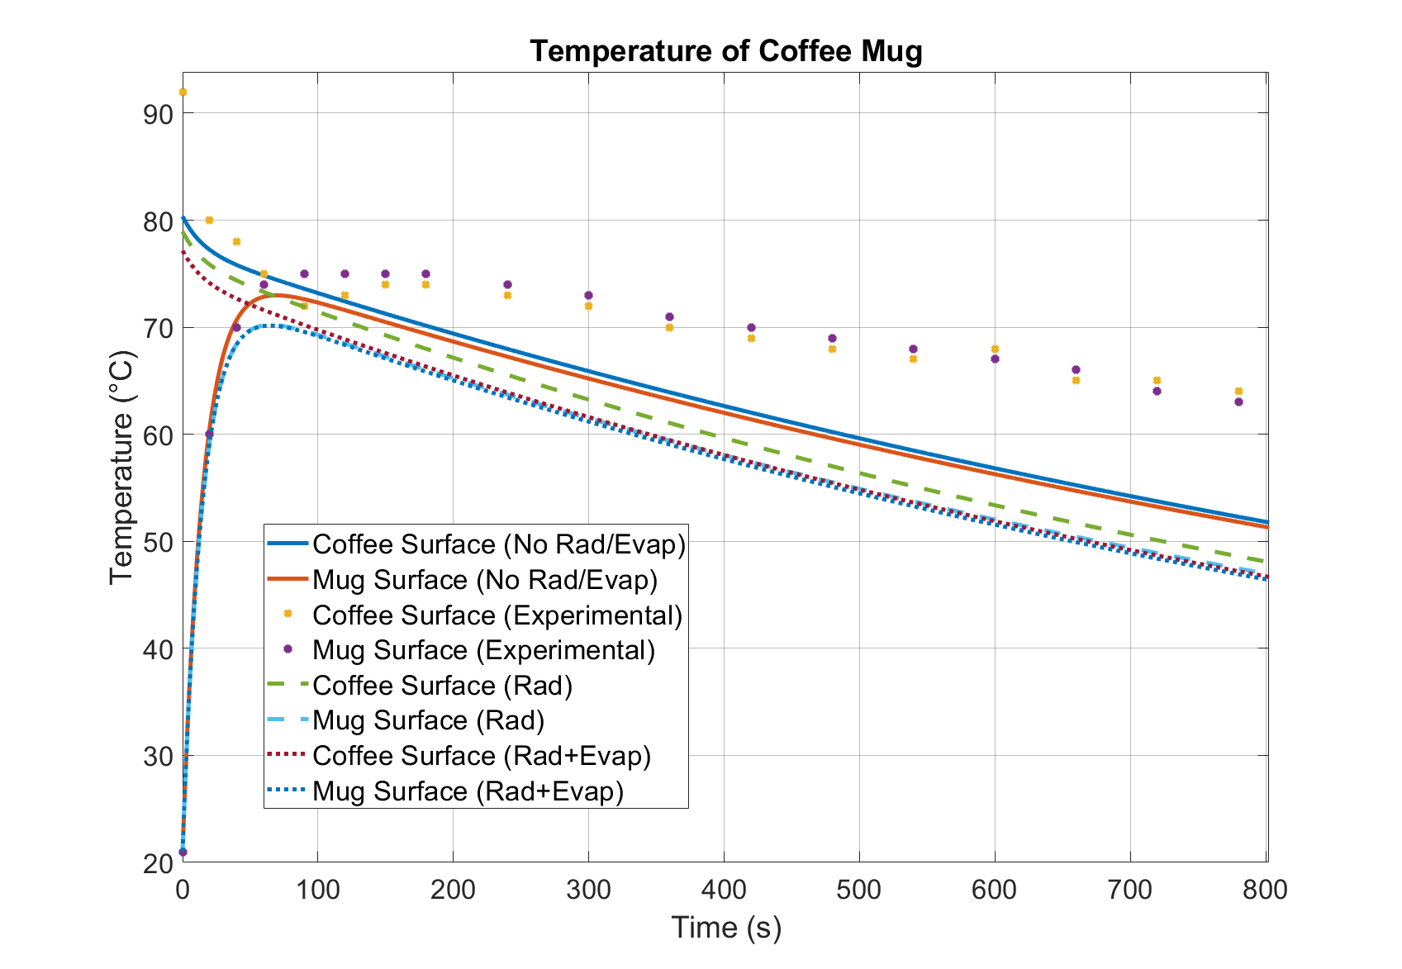Fig. 2: Plotting the Temperature of the Coffee-Mug with a Tighter Time Range

As stated earlier, a smaller time range must be established to look more closely at the actual action of each curve. Here, the purely convective and conductive model has the mug reaching peak temperature under two minutes while the coffee surface has a steep initial decrease in temperature that decreases in curvature to a near linear decrease. The addition of the radiative heat transfer, represented again by the dashed lines, more closely approximates experimental values with regards to the coffee surface, but gets less close with the mug surface. Adding the consideration of evaporation yielded the least accurate curves. They didn’t reach the peak temperature and had a sharper decrease in temperature which occurred much faster than the experimental curves.

**E)**

This model is satisfactory as it mirrors the general shape of the experimental data. The model was especially effective in the first minute but starts breaking down after 100 seconds. After that mark, the curves for each model had much lower temperature ranges in magnitude than the experimental data while still modeling the same type of curve. Improvements could potentially be made by focusing on potential ways the heat transfer of the mug changes over time after 100 seconds. Ideally adding and considering more methods of heat transfer would have more closely approximated the temperature curves, but the purely convective/conductive models for coffee and mug were the closest in magnitude to the real temperatures. Potentially, we could consider more modes in which convection and conduction occur in the coffee and look at it not as a lump mass, but as an object with an internal temperature gradient which effects the convection and conduction. It seems that considering more modes of heat transfer yielded less accurate curves that transferred heat too early. This conclusion isn’t logical because considering more modes of heat transfer should yield a more accurate model. This illogicality probably implies that the convective and conductive models heavily effect the coffee-mug system and that they aren’t being correctly modelled now. More considerations of the way convection and conduction occur can potentially fix the way that this model works and more closely approximate experimental behavior.

Discussion:

This question shows flaws in our current toolbox for heat transfer. Although we can now model multiple modes of heat transfer, they do not yield a predictive curve to the standards of the experimental data. This inability shows us that the way we look at our current tools needs to be improved. For example, conduction can be looked at as multiple discretized elements rather than a lump mass like we currently do.

**EX#2 – Wall In the House**

Problem Statement:

An oak wall in your house is flanked by two rooms with two different temperatures: one higher at 400 $℃$, and one lower at 100 $℃$. Model the surface temperatures of the wall while accounting for conductive and convective heat transfer. Then, guess at the radiative resistances while guessing at the surface temperatures. Taking that further, use MatLab to model multiple guesses at surface temperatures and plot the wall temperatures and surface temperatures as functions of time using the most accurate models that approximate steady state behavior of the system. How many iterations did it take to get the final, most accurate values? How do they compare to the model made from initially guessing?

Given:

1. The wall has a thickness of 0.2 m with a width of 0.3 m and height of 0.5 m

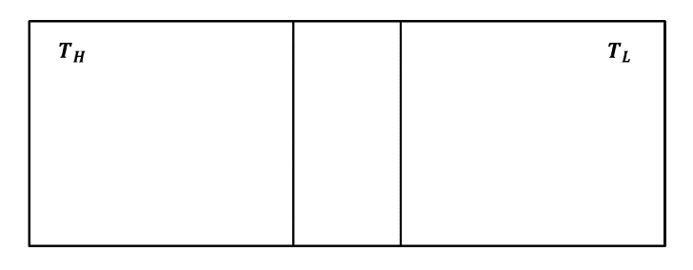

Fig.3 The Front View of The Wall Inside the Room

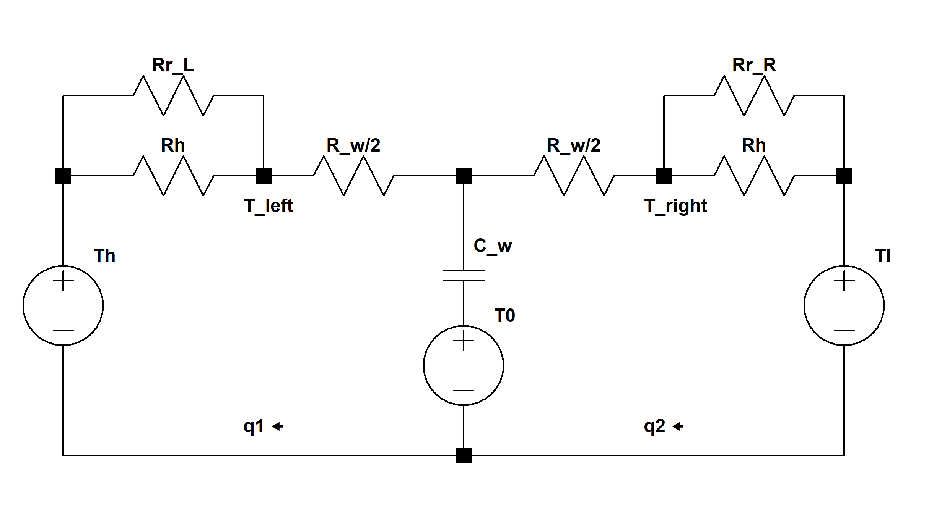

Fig.3 Thermal Circuit Diagram

**A)**

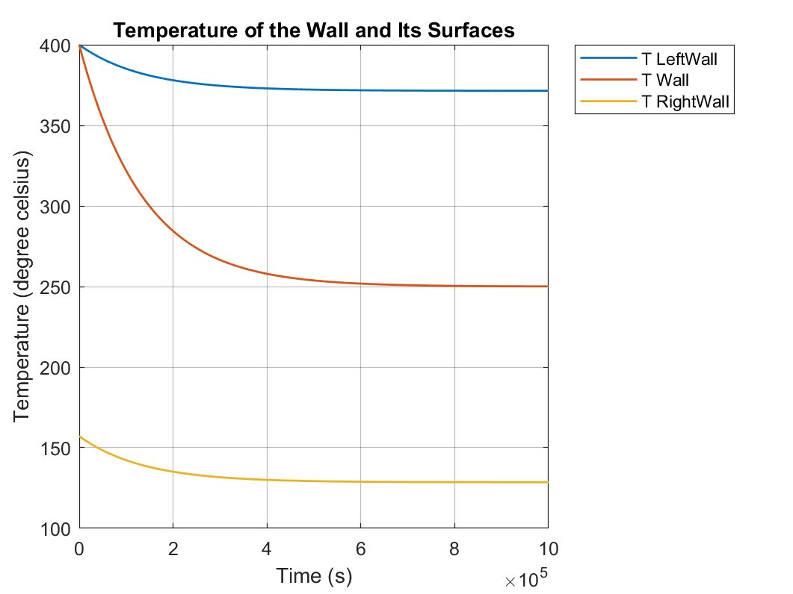

Fig.5 The Temperature Responses of the Wall and its Sides

**B)**

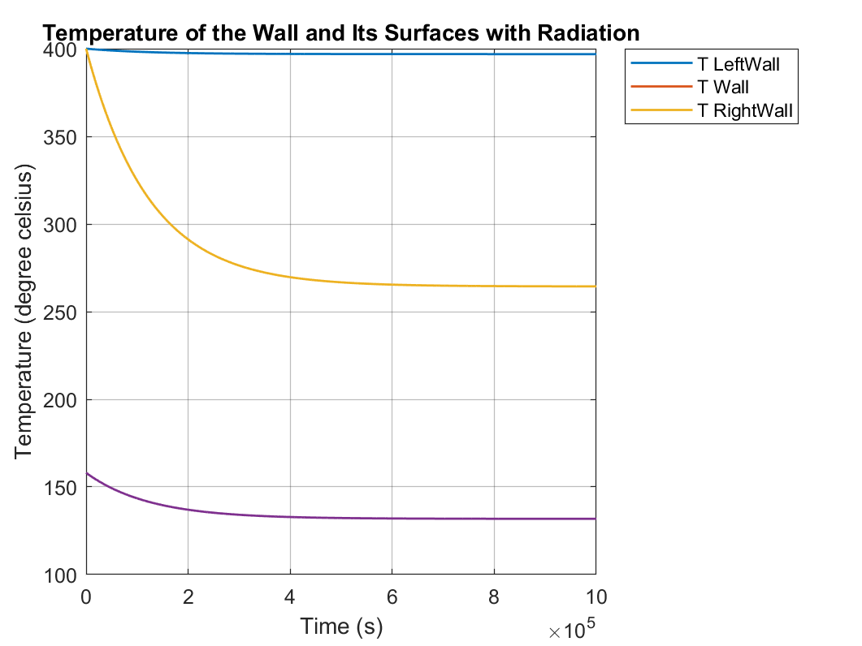

Fig.6 The Temperature Responses of the Wall and Its Sides with Radiation Involved

Adding radiation effect is equivalent with adding another thermal resistor in parallel with the convection resistor. Because the radiative resistance is smaller than the convection resistance, The combined resistance will be smaller than the convection resistances between the air and the wall, which increases the heat transfer rate in the steady state when the effect of the capacitor has dissipated over time. As a result, the steady state temperature of the left side wall increased. The wall temperature and right-side wall shifted up because of changing parameters.

**C)**

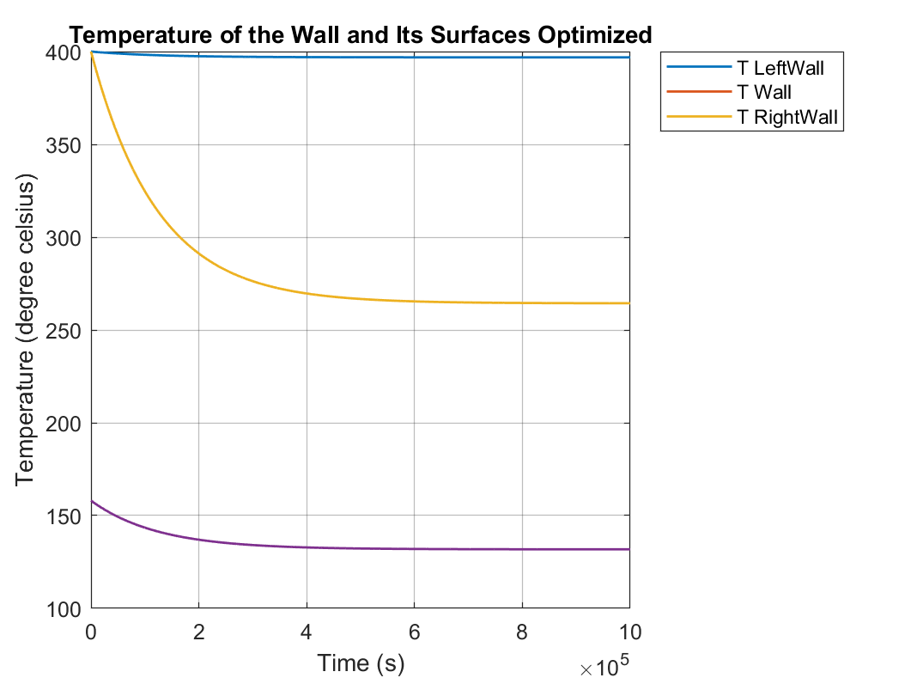

Fig.7 The Temperature Responses of the Wall and Its Sides with Radiation Optimized

i)

The final boundary temperature used for the left-side radiative resistance is 396.8764 $℃$, and 131.8154 $℃$ for the right-side radiative resistance. The final optimized radiative resistance for left side and right side are 0.1098 $\frac{K}{w}$ and 0.4974 $\frac{K}{w}$ respectively. To reach the result, it takes 14 iterations.

ii)

The temperature responses of the wall and its two sides are approximately the same between part b) and part c). The optimized temperature used to calculate left-side radiative resistance is lower than each iteration before, this will increase the radiative resistance. The optimized temperature used to calculate right-side radiative resistance is higher than each iteration before, this will decrease the radiative resistance at the right. As a result, the left side wall steady state temperature is slightly lower compare to the temperature in part b). The wall temperature is also slightly lower correspondingly.

Appendix

%% ME342_HW5_20200212

clc; clear all; close all;

%% EX#1 CONSTANTS

Tco = 81.7+273.15; %temp of coffee ini

Tf = 21+273.15; %amb temp

Tmo = 21+273.15; %temp of mug ini

m_m = 0.365; %mass of mug [kg]

vol = 0.41e-3; %volume of coffee 0.41 L

Din = 0.083; %inner diameter of cup [m]

w = 0.004; %wall thickness [m]

Dout = Din + 2*w; %outer diameter of cup

H = 0.098; %inner height [m]

Ho = 0.109; %outer height [m]

hb = Ho - H; %bottom thickness

L = vol/pi/(Din/2)^2; %length of coffee-mug contact

A_scm = pi*Din*L; %coffee-mug contact area side

A_bcm = pi*Din^2/4; %coffee-mug contact area bottom

A_sma = pi*Dout*Ho; %mug-air contact area side

A_bma = pi*Dout^2/4; %mug-air contact area bottom

%assume mug-air contact at the bottom doesnt happen

sigma = 5.669e-8; %stefan-boltzmann

eps = 0.96; %emissivity coffee

h_a = 6.8; %conv air

h_cm = 470; %conv coffee-mug

h_ca = 300; %conv coffee-air

h_evap = 10; %evap

h_rad = eps*sigma*(Tco^2 + Tf^2)*(Tco + Tf); %rad coffee

k_m = 1.5; %cond mug

c_m = 800; %cap mug

c_c = 4200; %cap coffee

rho_c = 1000; %density coffee

Rh_tca = 1/h_ca/A_bcm; %Rconv top coffee

Rh_ta = 1/h_a/A_bcm; %Rconv top air

Rr_tc = 1/h_rad/A_bcm; %Rrad top coffee

Rr_sm = 1/h_rad/A_sma; %Rrad top coffee

Revap = 1/h_evap/A_bcm; %Revap top coffee

Rh_scm = 1/h_cm/A_scm; %Rconv side coffee-mug

Rk_sm = w/k_m/A_scm; %Rcond side mug

C_sm = c_m*rho_c*(A_bma-A_bcm)*Ho; %Cap side mug

C_bm = c_m*rho_c*A_bcm*hb; %Cap bottom mug

C_m = C_sm+C_bm;

Rh_sma = 1/h_a/A_sma; %Rconv side mug-air

Rh_bcm = 1/h_cm/A_bcm; %Rconv bottom coffee-mug

Rk_bm = w/k_m/A_bcm; %Rcond side mug

C_c = rho_c*vol*c_c; %cap coffee

data = xlsread('coffee.xlsx');

t_r = data(:,1)*60;

T_coffeer = data(:,2);

T_mugr = data(:,3);

t = [0:0.1:250*60];

s = tf('s');

%% NO RAD OR EVAP

Y1 = [(1/(Rh_tca+Rh_ta)+1/(Rh_scm+Rk_sm/2)+1/(Rh_bcm+Rk_bm/2)+s*C_c) -1/(Rh_scm+Rk_sm/2) -1/(Rh_bcm+Rk_bm/2);

-1/(Rh_scm+Rk_sm/2) (1/(Rh_scm+Rk_sm/2)+1/(Rk_sm/2+Rh_sma)+s*C_sm) 0;

-1/(Rh_bcm+Rk_bm/2) 0 (1/(Rh_bcm+Rk_bm/2)+1/(Rk_bm/2)+s*C_bm)];

F1 = [Tco*C_c + Tf/s/(Rh_tca+Rh_ta);

Tmo*C_sm + Tf/s/(Rk_sm/2+Rh_sma);

Tmo*C_bm + Tf/s/(Rk_bm/2)];

T1 = Y1\F1;

Q_t1 = (T1(1)-Tf/s)/(Rh_tca+Rh_ta);

T_cofsurf1 = T1(1) - Rh_tca*Q_t1;

Q_s1 = (T1(2)-Tf/s)/(Rk_sm/2+Rh_sma);

T_mugsurf1 = T1(2) - Rk_sm/2*Q_s1;

temp_cofsurf1 = impulse(T_cofsurf1,t) - 273.15;

temp_mugsurf1 = impulse(T_mugsurf1,t) - 273.15;

figure(1)

plot(t,temp_cofsurf1,t,temp_mugsurf1,t_r,T_coffeer,'x',t_r,T_mugr,'*','LineWidth',3)

title('Temperature of Coffee Mug','FontSize',30)

xlabel('Time (s)','FontSize',20)

ylabel(['Temperature (' char(176) 'C)'],'FontSize',20)

set(gca,'FontSize',20)

grid on

set(gca,'GridAlpha',0.3)

legend('Location','northeast')

hold all

%% RAD

Rr_t = 1/(1/Rh_ta+1/Rr_tc);

Rr_s = 1/(1/Rh_sma+1/Rr_sm);

Y2 = [(1/(Rh_tca+Rr_t)+1/(Rh_scm+Rk_sm/2)+1/(Rh_bcm+Rk_bm/2)+s*C_c) -1/(Rh_scm+Rk_sm/2) -1/(Rh_bcm+Rk_bm/2);

-1/(Rh_scm+Rk_sm/2) (1/(Rh_scm+Rk_sm/2)+1/(Rk_sm/2+Rr_s)+s*C_sm) 0;

-1/(Rh_bcm+Rk_bm/2) 0 (1/(Rh_bcm+Rk_bm/2)+1/(Rk_bm/2)+s*C_bm)];

F2 = [Tco*C_c + Tf/s/(Rh_tca+Rr_t);

Tmo*C_sm + Tf/s/(Rk_sm/2+Rr_s);

Tmo*C_bm + Tf/s/(Rk_bm/2)];

T2 = Y2\F2;

Q_t2 = (T2(1)-Tf/s)/(Rh_tca+Rr_t);

T_cofsurf2 = T2(1) - Rh_tca*Q_t2;

Q_s2 = (T2(2)-Tf/s)/(Rk_sm/2+Rr_s);

T_mugsurf2 = T2(2) - Rk_sm/2*Q_s2;

temp_cofsurf2 = impulse(T_cofsurf2,t) - 273.15;

temp_mugsurf2 = impulse(T_mugsurf2,t) - 273.15;

figure(1)

plot(t,temp_cofsurf2,'--',t,temp_mugsurf2,'--','LineWidth',3)

title('Temperature of Coffee Mug','FontSize',30)

xlabel('Time (s)','FontSize',20)

ylabel(['Temperature (' char(176) 'C)'],'FontSize',20)

set(gca,'FontSize',20)

grid on

set(gca,'GridAlpha',0.3)

hold all

%% RAD+EVAP

Rr_te = 1/(1/Rh_ta+1/Rr_tc+1/Revap);

Rr_s = 1/(1/Rh_sma+1/Rr_sm);

Y3 = [(1/(Rh_tca+Rr_te)+1/(Rh_scm+Rk_sm/2)+1/(Rh_bcm+Rk_bm/2)+s*C_c) -1/(Rh_scm+Rk_sm/2) -1/(Rh_bcm+Rk_bm/2);

-1/(Rh_scm+Rk_sm/2) (1/(Rh_scm+Rk_sm/2)+1/(Rk_sm/2+Rr_s)+s*C_sm) 0;

-1/(Rh_bcm+Rk_bm/2) 0 (1/(Rh_bcm+Rk_bm/2)+1/(Rk_bm/2)+s*C_bm)];

F3 = [Tco*C_c + Tf/s/(Rh_tca+Rr_te);

Tmo*C_sm + Tf/s/(Rk_sm/2+Rr_s);

Tmo*C_bm + Tf/s/(Rk_bm/2)];

T3 = Y3\F3;

Q_t3 = (T3(1)-Tf/s)/(Rh_tca+Rr_te);

T_cofsurf3 = T3(1) - Rh_tca*Q_t3;

Q_s3 = (T3(2)-Tf/s)/(Rk_sm/2+Rr_s);

T_mugsurf3 = T3(2) - Rk_sm/2*Q_s3;

temp_cofsurf3 = impulse(T_cofsurf3,t) - 273.15;

temp_mugsurf3 = impulse(T_mugsurf3,t) - 273.15;

figure(1)

plot(t,temp_cofsurf3,':',t,temp_mugsurf3,':','LineWidth',3)

title('Temperature of Coffee Mug','FontSize',30)

xlabel('Time (s)','FontSize',20)

ylabel(['Temperature (' char(176) 'C)'],'FontSize',20)

set(gca,'FontSize',20)

grid on

set(gca,'GridAlpha',0.3)

hold all

legend('Coffee Surface (No Rad/Evap)','Mug Surface (No Rad/Evap)','Coffee Surface (Experimental)','Mug Surface (Experimental)','Coffee Surface (Rad)','Mug Surface (Rad)','Coffee Surface (Rad+Evap)','Mug Surface (Rad+Evap)','FontSize',20)

hold all

clc;

clear all;

close all;

%% QUESTION 2

t_final=1e6;

dt=4;

t=(0:dt:t_final).';

TH=400+273.15; %c

TL=100+273.15; %c

T0=400+273.15; % c

k_w=0.16; %W/m*K

Rw=0.2/(k_w*0.3*0.5);%K/w

e=0.89;

sig=5.669E-8; %w/m^2*K^4

hrH=sig*e*4*TH^3;

hrL=sig*e*4*TL^3;

RrH=1/(hrH*0.3*0.5); %K/w

RrL=1/(hrL*0.3*0.5); %K/w

hair=6.8; %w/m^2*k

Rh=1/(hair*0.3*0.5); %K/w

C=2380*0.2*0.3*0.5*740; %J/K

%part a)

s=tf('s');

A=[Rh+Rw/2+1/(s*C),-1/(s*C);

-1/(s*C),1/(s*C)+Rw/2+Rh];

B=[(TH-T0)/s,(T0-TL)/s].';

q_s=A\B;

T_left=TH/s-q_s(1)*Rh;

T_left_t=impulse(T_left,t)-273.15;

T_wall=TH/s-q_s(1)*(Rh+Rw/2);

T_wall_t=impulse(T_wall,t)-273.15;

T_right=TL/s+q_s(2)*Rh;

T_right_t=impulse(T_right,t)-273.15;

figure(1)

plot(t,T_left_t,'LineWidth',1.1)

hold on

plot(t,T_wall_t,'LineWidth',1.1)

hold on

plot(t,T_right_t,'LineWidth',1.1)

title('Temperature of the Wall and Its Surfaces','FontSize',14)

xlabel('Time (s)','FontSize',12)

ylabel('Temperature (degree celsius)','FontSize',12)

set(gca,'FontSize',10)

grid on

set(gca,'GridAlpha',0.3)

legend({'T LeftWall','T Wall','T RightWall'},'Location','bestoutside')

%% part b

RhH=(RrH*Rh)/(RrH+Rh);

RhL=(RrL*Rh)/(RrL*Rh);

A=[RhH+Rw/2+1/(s*C),-1/(s*C);

-1/(s*C),1/(s*C)+Rw/2+RhL];

B=[(TH-T0)/s,(T0-TL)/s].';

q_s=A\B;

T_left=TH/s-q_s(1)*RhH;

T_left_t=impulse(T_left,t)-273.15;

T_wall=TH/s-q_s(1)*(RhH+Rw/2);

T_wall_t=impulse(T_wall,t)-273.15;

T_right=TL/s+q_s(2)*RhL;

T_right_t=impulse(T_right,t)-273.15;

figure(2)

plot(t,T_left_t,'LineWidth',1.1)

hold on

plot(t,T_wall_t,'LineWidth',1.1)

hold on

plot(t,T_wall_t,'LineWidth',1.1)

hold on

plot(t,T_right_t,'LineWidth',1.1)

title('Temperature of the Wall and Its Surfaces with Radiation','FontSize',14)

xlabel('Time (s)','FontSize',12)

ylabel('Temperature (degree celsius)','FontSize',12)

set(gca,'FontSize',10)

grid on

set(gca,'GridAlpha',0.3)

legend({'T LeftWall','T Wall','T RightWall'},'Location','bestoutside')

%% part c

T_left_tem=T_left_t(250000)+273.15;

T_left_sur=400+273.15;

T_right_tem=T_right_t(250000)+273.15;

T_right_sur=100+273.15;

while (T_left_sur-T_left_tem) >0.001

T_left_sur=T_left_sur-0.6*(T_left_sur-T_left_tem);

while (T_right_tem-T_right_sur) >0.001

T_right_sur=T_right_sur+0.6*(T_right_tem-T_right_sur);

hrH=sig*e*4*T_left_sur^3;

hrL=sig*e*4*T_right_sur^3;

RrH=1/(hrH*0.3*0.5)

RrL=1/(hrL*0.3*0.5)

RhH=(RrH*Rh)/(RrH+Rh);

RhL=(RrL*Rh)/(RrL*Rh);

A=[RhH+Rw/2+1/(s*C),-1/(s*C);

-1/(s*C),1/(s*C)+Rw/2+RhL];

B=[(TH-T0)/s,(T0-TL)/s].';

q_s=A\B;

T_left=TH/s-q_s(1)*RhH;

T_right=TL/s+q_s(2)*RhL;

T_left_t=impulse(T_left,t);

T_left_tem=T_left_t(250000);

T_right_t=impulse(T_right,t);

T_right_tem=T_right_t(250000);

end

end

hrH=sig*e*4*T_left_sur^3;

hrL=sig*e*4*T_right_sur^3;

RrH=1/(hrH*0.3*0.5);

RrL=1/(hrL*0.3*0.5);

A=[RhH+Rw/2+1/(s*C),-1/(s*C);

-1/(s*C),1/(s*C)+Rw/2+RhL];

B=[(TH-T0)/s,(T0-TL)/s].';

q_s=A\B;

T_left=TH/s-q_s(1)*RhH;

T_left_t=impulse(T_left,t)-273.15;

T_wall=TH/s-q_s(1)*(RhH+Rw/2);

T_wall_t=impulse(T_wall,t)-273.15;

T_right=TL/s+q_s(2)*RhL;

T_right_t=impulse(T_right,t)-273.15;

figure(3)

plot(t,T_left_t,'LineWidth',1.1)

hold on

plot(t,T_wall_t,'LineWidth',1.1)

hold on

plot(t,T_wall_t,'LineWidth',1.1)

hold on

plot(t,T_right_t,'LineWidth',1.1)

title('Temperature of the Wall and Its Surfaces Optimized','FontSize',14)

xlabel('Time (s)','FontSize',12)

ylabel('Temperature (degree celsius)','FontSize',12)

set(gca,'FontSize',10)

grid on

set(gca,'GridAlpha',0.3)

legend({'T LeftWall','T Wall','T RightWall'},'Location','bestoutside')